WCST 2026 Da Nang Paper Title
Indicate Submission Type: Completed Research Paper, Short Paper
<Authors and abstracts SHOULD NOT BE in the file that contains the body of the paper — they are added during the submissions process in the review system.> Once submitted, no changes in paper or authorship are allowed.

Introduction
We ask that authors follow these basic guidelines when submitting to WCST. In essence, you should format your paper exactly like this document. The easiest way to use this template is to replace the placeholder content with your own material. The template file contains specially formatted styles (e.g., Normal, Heading, Bullet, References, Title, Author, Affiliation) that are designed to reduce the work in formatting your final submission.

Page Size and Spacing
On each page, your material (not including the header and footer) should fit within a rectangle of 16.5 x 22.8 cm (6.5 x 9 in.), centered on a US letter page, beginning 1.27 cm (0.5 in.) from the top of the page. Please adhere to the US letter size only (in MS Word, you can check the page format in the menu: File --> Page Setup). If you cannot do so, please contact the review coordinator for assistance. All final publications will be formatted and displayed in US letter size. Right margins should be justified, not ragged. All margins must measure 1” (2.5 cm) around. Beware, especially when using this template on a Macintosh, Word may change these dimensions in unexpected ways.
Please ensure your manuscript complies with the following instructions:
- Line spacing should be single (exactly 1.0);
- Margins should be 1 inch (2.54 cm);
- Do not change character or word spacing;
- Please do not use double spaces between sentences – this is a tradition no longer necessary on modern word processors;
- Please do not edit the styles in this template;
- Please ensure all text is justified, not “ragged” ( = left-aligned).
Non-compliance of these instructions may lead to desk rejection of your paper.

Length
Each type of submission (completed research papers, short papers) has specific page length requirements. See the requirements specific to each type of submission in the Types of Submissions & Instructions document. Any submission that exceeds page length limits will be rejected without review.

Title
Your paper’s title must use the “Title” style in this template, defined as 20-point Times New Roman, bold. Ensure proper title case capitalization (e.g., “The Next Frontier of Information Systems” rather than “the next frontier of Information systems”).
Capitalize all proper nouns and all major words. Do not capitalize articles (the, a), coordinating conjunctions (and, but, or, for, nor, etc.), or prepositions (on, at, to, from, by, etc.), except when they are the first word of the title.

Normal or Body Text
All body text must use the “Normal” style defined as 10-point Times New Roman. Use sans-serif or monospaced fonts (such as Arial or Courier) only for special purposes, such as source code text (SpecialStyle).

Sections
The heading of each section must use the “Heading 1” style in 13-point Times New Roman, bold, left-aligned, with each major word capitalized. Section headings must not be numbered.

Subsections
Headings of subsections must use the “Heading 2” style in 11-point Times New Roman, bold italics, with appropriate capitalization of each major word. Do not capitalize articles (the, a, an), prepositions (of, in, on, at, to, from, by, etc.), or coordinating conjunctions (and, but, or, for, nor, etc.) unless they are the first word of the heading.

Sub-subsections
Headings for sub-subsections must use the “Heading 3” style in 10-point Times New Roman, bold, with the initial letters of each major word capitalized. Do not use any additional heading levels beyond this.

Figures, Tables & Captions
Place figures and tables as close as possible to the relevant text, preferably near where they are first mentioned.
Captions must use the “Caption” style in 10-point Times New Roman, bold. They should be numbered (e.g., “Table 1” or “Figure 2”), centered, and placed beneath the corresponding figure or table. The words “Figure” and “Table” must always be spelled out in full (e.g., “Figure” rather than “Fig.”) wherever they appear. Because the proceedings will be made available online, the use of color figures is permitted.

Inserting Images
Occasionally MS Word generates larger-than-necessary PDF files when images inserted into the document are manipulated in MS Word. To minimize this problem, use an image editing tool to resize the image at the appropriate printing resolution (usually 300 dpi), and then insert the image into Word using Insert | Picture | From File...
As indicated in Figure 1, using tables to hold places can work very well in Word. If you want to copy a figure from another application (such as PowerPoint) and then paste to the place where you want your figure to be, make sure that (1) the figure stays in the position, and (2) it does not take up too much space. You can ensure the former by double clicking the figure, then go to “Layout” tab, and select “In line with text.” To ensure the latter, use “Paste Special,” then select “Picture.” You can resize the figure to your desired size once it is pasted.

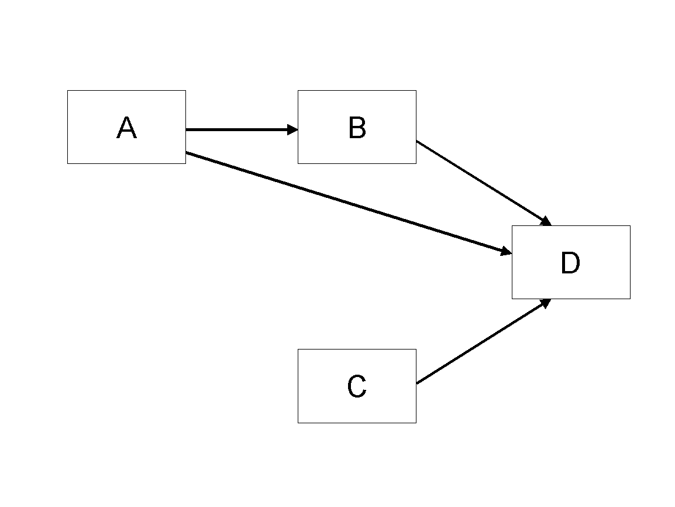
Figure 1. Modified Research Model

Table Style
Inserting a table in the text can work well. You may want to adjust the vertical spacing of the text in the tables. (In Word, use Format | Paragraph… and then the Line and Page Breaks tab. Generally, text in each field of a table will look better if it has equal amounts of spacing above and below it, as in Table 1.)
 | Treatment 1 | Treatment 2
Setting A | 125 | 95
Setting B | 85 | 102
Setting C | 98 | 85
Table 1. A Very Nice Table

Language, Style, and Content
With regard to spelling and punctuation, you may use any dialect of English (e.g., British, Canadian, US, etc.) provided this is done consistently. Hyphenation is optional. To ensure suitability for an international audience, please pay attention to the following:
- Write in a straightforward style.
- Try to avoid long or complex sentence structures.
- Briefly define or explain all technical terms that may be unfamiliar to readers.
- Explain all acronyms the first time they are used in your text – e.g., “information and communication technology (ICT)”.
- Explain local references (e.g., not everyone knows all city names in a particular country).
- Be careful with the use of gender-specific pronouns (he, she) and other gendered words (chairman, manpower, man-months). Use inclusive language that is gender-neutral (e.g., they, s/he, chair, staff, staff-hours, person-years).

Conclusion
It is important that you write for a general audience. It is also important that your work is presented in a professional fashion. This guideline is intended to help you achieve that goal. By adhering to the guideline, you also help the conference organizers tremendously in reducing our workload and ensuring impressive presentation of your conference paper. We thank you very much for your cooperation and look forward to receiving a professional looking, camera-ready version.

Acknowledgements (optional)
Please do not add acknowledgements to your original submission because it will help identify authors. Acknowledgements may be added later, if the paper is accepted.
Use of generative artificial intelligence (AI): If you have used generative AI, you must clearly describe how it was used in the preparation of the paper and acknowledge the authors’ responsibility for the final version.

References and Citations
References should be listed alphabetically by author name at the end of the paper in conformance with APA 7th edition. In-text citations should be indicated by the author’s last name and year of publication, e.g., (Koo, 2019) or Koo (2019). References must be complete, i.e., include, as appropriate, volume, number, month, publisher, city and state, editors, last name & initials of all authors, page numbers, etc. If you use EndNote, be aware that different versions of the software change the styles, creating some inconsistencies.
Your references should comprise only published (or preprint) materials accessible to the public. Proprietary information may not be cited.
References should be ordered in alphabetic order.

References

<<<Please ensure that all references are present, complete, and accurate as per the examples below, including DOIs>>>
Benbasat, I., & Zmud, R. W. (2003). The identity crisis within the IS discipline: Defining and communicating the discipline's core properties. MIS Quarterly, 27(2), 183-194. https://doi.org/10.2307/30036527
Bonini, C. P. (1963). Simulation of information and decision systems in the firm. Prentice-Hall.
Broadbent, M., Weill, P., O’Brien, T., & Neo, B. S. (1996). Firm context and patterns of IT infrastructure capability. Proceedings of the 14th International Conference on Information Systems, 13, 174-194. https://aisel.aisnet.org/icis1996/13
Carroll, J. (2005). The Blacksburgh Electronic Village: A study in community computing. In P. van den Besselaar & S. Kiozumi (Eds.), Digital Cities III: Information Technologies for Social Capital (pp. 43-65). Springer-Verlag. https://doi.org/10.1007/11407546_3
Gretzel, U., Sigala, M., Xiang, Z., & Koo, C. (2015). Smart tourism: foundations and developments. Electronic markets, 25(3), 179-188. https://doi.org/10.1007/s12525-015-0196-8

