THE BLUE COASTAL CITY
DA NANG CITY TOUR
Duration: 01 Day

Tour Highlights
- Visit Son Tra Peninsula, Linh Ung Pagoda, and the Marble Mountains
- Check in at Dragon Bridge, Love Bridge, and My Khe Beach

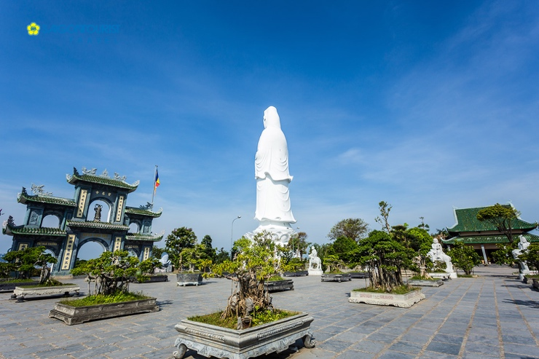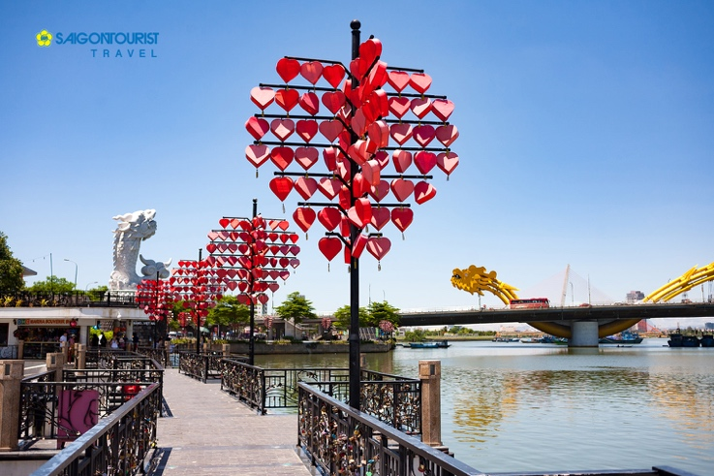

Tour Itinerary
- 08:00 The vehicle and Saigontourist tour guide pick up guests and depart to visit Linh Ung Pagoda – Son Tra Peninsula, located approximately 10 km from Da Nang city center. Son Tra Peninsula is an extension of the Truong Son mountain range reaching the sea and is one of the most scenic landmarks of Da Nang. The area became even more famous after the completion of Linh Ung Pagoda (Son Tra) in 2009–2010, featuring the second-tallest Lady Buddha statue in Vietnam at 67 meters high.
Continue to visit the Marble Mountains (Ngu Hanh Son).
- Visit Non Nuoc Stone Carving Village, one of the four ancient craft villages of Quang Nam – Da Nang.
- Ascend Thuy Son Mountain, the largest and most beautiful mountain in the Marble Mountains complex.
- Explore famous attractions from Lower Level to Upper Level such as Xa Loi Tower, Linh Ung Pagoda I, Tang Chon Cave, Van Thong Cave, Huyen Khong Grotto, Vong Giang Pavilion, and Tam Thai Pagoda.
- Descend the mountain on foot and transfer to a local restaurant for rest and lunch.
11:00 Enjoy local specialties for lunch.
Afternoon
- Visit and check in at Love Bridge, Dragon Bridge, and stroll along the Han River pedestrian street, enjoying the romantic riverside scenery.
- Continue to visit Da Nang Cathedral (Rooster Church) – a Gothic-style church featuring soaring lines and pointed arches. Inside, the church displays paintings and statues illustrating biblical events in the traditional Western church style.
- 15:00 Return to the original pick-up point. End of tour.

GROUP | 2 PAX | 3-4 PAX | 5-6 PAX | 7-10 PAX | 11-15 PAX | 16-20 PAX
CAR | 4 SEATS | 7 SEATS | 16 SEATS | 16 SEATS | 30 SEATS | 35 SEATS
PRICE (PAX/VND) | 2.650.000 | 2.000.000 | 1.500.000 | 1.250.000 | 1.150.000 | 970.000

Children Policy
- Children under 5 years old: Free of charge (parents cover any additional expenses)
- Children from 5 to under 11 years old: 80% of adult price
- Children from 11 years old and above: Adult price applies

Tour Price Includes
- Air-conditioned transportation as per itinerary
- Professional tour guide throughout the journey
- 01 standard lunch as per program (400.000VND/pax)
- Entrance fees to all attractions mentioned in the itinerary
- Bottled water and cold towels: 02 units/person/day
- VAT as regulated
- Complimentary travel insurance

Tour Price Excludes
- Personal expenses and other costs not mentioned above
- Beverages during meals

Travel Insurance Information
Saigontourist Travel Service Company provides COMPLIMENTARY TRAVEL INSURANCE for all guests joining package tours nationwide:
- International Tours: Maximum coverage up to VND 1,200,000,000 per guest per case.
For tours to Europe, America, Africa, Australia, Japan, the United Kingdom, and the United Arab Emirates, coverage is up to VND 2,400,000,000 per guest per case.
- Domestic Tours: Maximum coverage up to VND 150,000,000 per guest per case.

