THE PATH TO FAIRYLAND – BA NA HILLS
GOLDEN BRIDGE
Duration: 01 Day

Tour Highlights
- Experience the world-record cable car system to Ba Na Hills
- Visit Debay Wine Cellar, French Village, and check in at the iconic Golden Bridge
- Enjoy four seasons in one day, immerse yourself in a sea of clouds and breathtaking natural scenery

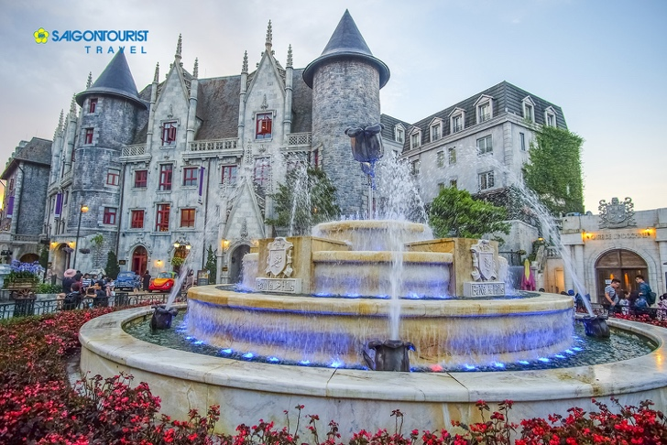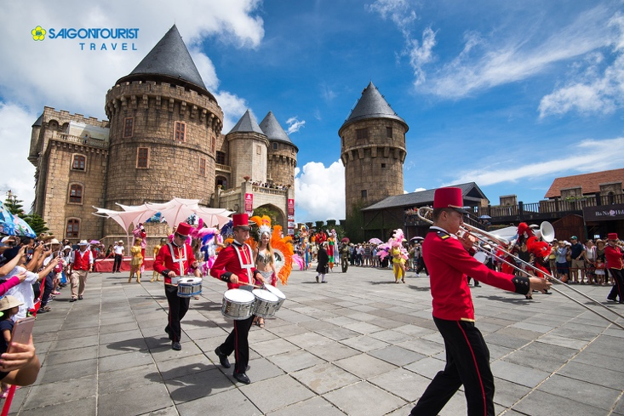
Itinerary
Morning: The vehicle and Saigontourist tour guide pick up guests at the meeting point and depart for Ba Na Hills Tourist Area.
09:00 Take the cable car up to Ba Na Hills and begin sightseeing:
- Le Jardin D’Amour Flower Garden – A romantic garden where visitors feel as if they have stepped into a world filled with love, flowers, and lush greenery.
- Debay Wine Cellar – Built by the French in 1923. “Debay” was the name of the French captain who discovered Ba Na and proposed the construction of a resort for the Governor-General of Indochina.
- Linh Phong Bao Tower – A majestic 9-storey tower on the peak of Ba Na Mountain. Each level features four bronze bells symbolizing sacred echoes of this spiritual landmark.
- Golden Bridge – One of the most iconic check-in spots, attracting millions of visitors to Da Nang.
Lunch: Enjoy a buffet lunch at a restaurant in Ba Na Hills.
Afternoon: Continue visiting:
- French Village – Designed as a miniature picture of France with squares, churches, towns, and hotels. The pointed rooftops against the blue sky create a fairy-tale atmosphere reminiscent of distant France.
- Fantasy Park – Inspired by Jules Verne’s famous novels Journey to the Center of the Earth and Twenty Thousand Leagues Under the Sea. This indoor amusement park offers a vibrant entertainment world with exciting games, especially enjoyable for children.
15:30 Take the cable car down, bid farewell to Ba Na Hills. The vehicle and tour guide transfer the group back to Da Nang. End of tour.

GROUP | 2 PAX | 3-4 PAX | 5-6 PAX | 7-10 PAX | 11-15 PAX | 16-20 PAX
CAR | 4 seats | 7 seats | 16 seats | 16 seats | 30 seats | 35 seats
PRICE (PAX/VND) | 3.350.000 | 2.750.000 | 2.250.000 | 2.050.000 | 1.900.000 | 1.750.000

Children Policy
- Children under 1m: Free of charge (parents cover any incidental expenses if applicable)
- Children from 1m to under 1.4m: 80% of adult price
- Children from 1.4m and above: Adult price applies

Tour Price Includes
- Entrance fees to all attractions as per itinerary
- 01 buffet lunch at Ba Na Hills restaurant
- Air-conditioned transportation as per program
- Saigontourist professional tour guide
- Drinking water on the bus: 02 bottles (500ml/person/day)
- Complimentary travel insurance
- VAT as regulated

Tour Price Excludes
- Personal expenses outside the program
- Tips for tour guide and driver (if any)

Travel Insurance Information
Saigontourist Travel Service Company provides COMPLIMENTARY TRAVEL INSURANCE for all guests joining package tours nationwide:
- International Tours: Maximum coverage up to VND 1,200,000,000 per guest per case.
For tours to Europe, America, Africa, Australia, Japan, the United Kingdom, and the United Arab Emirates, coverage is up to VND 2,400,000,000 per guest per case.
- Domestic Tours: Maximum coverage up to VND 150,000,000 per guest per case.

